# **Chapter 1**

## **Introduction**

* 1. **Project Introduction**

Analysing the current situation of Nepal, there are very few numbers of stores that sells and buys used books inside Kathmandu valley and fewer stores outside the valley. Whether it be school/colleges textbooks, novels, magazines or children’s story book, people who love books just can’t seem to sell off their valuable books to scrap buyers at penny rates. Those books just stack up on your rack never to be used again. For this “Book Quest” is proposed.

* 1. **Justification for the project**

The project is further justified in background of the project and problem statement.

* + 1. **Background of the project**

People start reading book at the early age of 4-5. So, you can imagine how many books one adult owns in their life. Some people sell off their books to recyclers, some giveaway to their friends or relatives and some people just pack it up in boxes. ‘Book Quest’ is introduced to change the concept of buying and selling of used books. It is a web application which provides an e-commerce platform to sell and buy books.

* + 1. **Problem statement**

Physical book stores are located at certain areas, which might be difficult to find and also inconvenient for many people living at distant places. Even if found the store, there are high chances of customer dissatisfaction as the selling prices might be high and buying price might be low. “Book Quest” is an easy to use application which allows users to both buy and sell used book that are in good conditions at affordable price. People with internet access can use the application from all over Nepal and comfortably search or upload their books. It is an easy way of disposing your book collection to good hands and make money out of it.

* 1. **Description of the project**

As the name suggests “Book Quest” is a web application which doesn’t buy the book itself but creates a platform where buyers meet sellers. The main features that are to be found in “Book Quest” are listed below.

* + 1. **Features of the project**

The list of features are:

* ‘User login’ so that each user has their own account to use the application.
* ‘Search’ to make it easier to search by key words and also ‘similar searches’ which suggests the related books that user might like.
* ‘Chat’ to communicate between users to make the deal.
* ‘FAQ’ and ‘Questionnaires’ for raising questions to be clear about how the application works.
* ‘Safety tips’ to aware user about the negative consequences.
  1. **Overview of the project**

The application is developed to reshape the thinking of the people about old used books. It is a platform where you can sell or buy your old books at a reasonable price. It provides convenience to user as they can surf through the website staying at home and take advantage of the deals.

# **Chapter 2**

## **Scope of the Project**

* 1. **Scope**

This application eliminates the need of visiting stores saving a lot of time of the user. The users can sell or buy book following few steps using their devices like phones, Pc connected to the internet which is really handy.

* 1. **Limitations**

Along with the advantageous features there are limitations of the project too. They are listed below:

* The users are supposed to determine the price, so buyers can waste a lot of time bargaining or searching least priced books.
* Although safety tips are available, there are still chances of fraud.
* The delivery charges might be expensive and also the application is limited within Nepal.
* Despite of the description of book condition and uploaded photos, the book might not be at the described condition which leads to dissatisfaction.
  1. **Aims**
* The main aim of this application is to provide an online marketplace for people to make selling and buying of books easier.
* Also, the project aims at convenience of people by saving time and energy of the users from visiting stores and deal with its ruckus.
  1. **Objectives**

For any aim to be accomplished a set of objectives must be fulfilled. The objectives of the project ‘Book Quest’ are:

* To provide user with best deals.
* To save time and energy of user by providing online marketplace.
* To change the concept of people about buying and selling of old books.
* To make useful reuse of old books instead of giving it away to scrap buyers.
* To provide effective communication between users for better and safe deals.
  1. **Overview of the scope**

Looking at the overall scope, the project ‘Book Quest’ brings a new concept of handing over old books to the people needing them in Nepal. As this project make selling/buying of books easier by simply following few steps which is a better way of decomposing your old books making money from it or getting a new one at cheaper rates. These facilities will surely encourage most of the population to use the application.

# **Chapter 3**

## **Development Methodology**

For this project, Waterfall methodology is used.

* 1. **Description of the Methodology**

Waterfall model is the first model process to be introduced known as linear sequential life cycle model. It is an easy to use and understand methodology where each stage must be completed before starting another stage which helps to keep record of the performances and if the project is completed within a deadline.

The progress of waterfall model is seen flowing steadily downwards through following phases:

* Requirements

In this phase all the possible requirements of the application must be analysed and documented in a proper manner as in waterfall model there is no rolling back to previous phase.

* Design

The specified requirements from the previous phase are studied and the design of the application is prepared. In this phase architecture diagram such as class diagram, data flow diagram and other design documents are created. It defines overall architecture of the application by determining the hardware and software specifications.

* Implementation

With the help of previous phase, an application is first developed in small programs called unit. Then, each unit gets tested for its performance. If successful then it is integrated to a system.

* Testing

After development of each unit in implementation phase, unit testing is performed, if successful it is further integrated to a system. Further, it is tested for faults.

* Deployment

After testing is done, any faults or failures are resolved by the developers. Then the application is released into the market.

* Maintenance

Only developing a system is not sufficient. We must make sure that the system works fine and must be updated frequently, for that patches must be released. Also, new features and versions must be made available.

Waterfall methodology is used in this web-application by performing following tasks below:

* Deciding what will be delivered early in the lifecycle which makes planning and designing more direct.
* As design is completed at the early phase, application components are developed in parallel to integration with external application.
* Testing scripts are prepared while coding is underway.

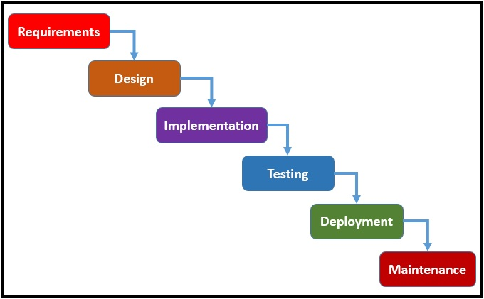

Figure 1: Waterfall Model

* 1. **Design pattern**

MVC is a design pattern that is used to separate Model, View and Control of the system. It supports separation of components by isolating the view from the controller from the model based on their authority. It helps to create maintainability by preventing the system from creating other complex systems.

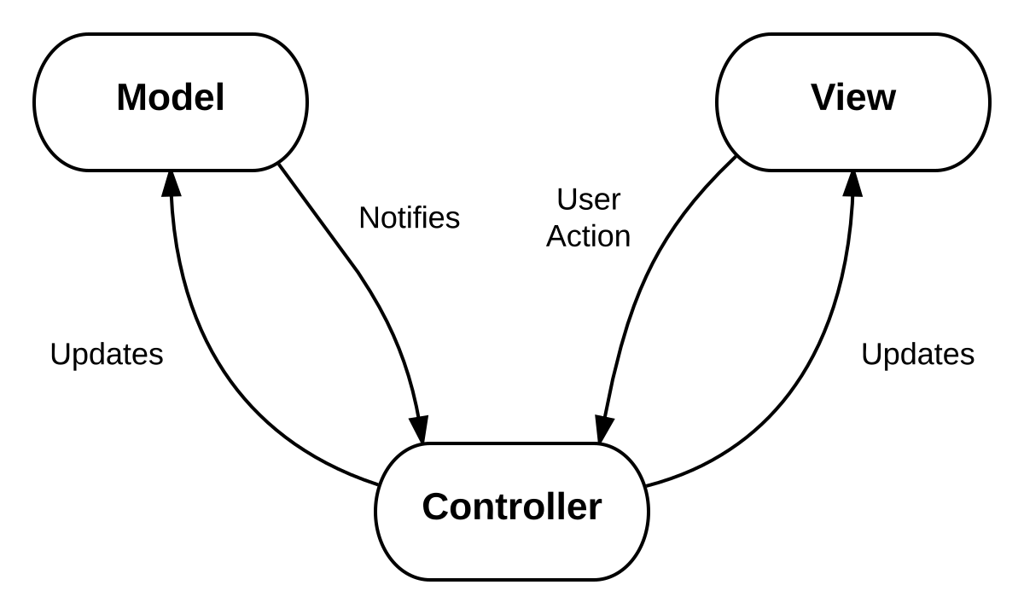

Figure 2: Model View Controller

* **Model-** Itis responsible for managing the data; it is used to store and retrieve entities used by an application, often from a database, and it also contains the implemented application logic.
* **View-** It is responsible for displaying the data provided by the model in a specific format. It is attached to its model part and communicate through questions. It may send appropriate messages to the model and update it.
* **Controller-** Ithandles the model and view layers to work together. It receives a request from the client, invokes the model to perform the requested operations and sends the data to the view. The view formats the data to be presented to the user, in a web application as an html output.

MVC is used in this web-application by performing following tasks below:

* The application is made flexible by separating model and view.
* The web-application can be transformed by writing new view module.
* Each module are tested and debugged separately.
  1. **Architecture**

3 tier is well structured architecture which consists of three layer presentation layer that comprises desktops and workstation interacting with the server known as application tier which is connected to the database tier. It is client structure architecture in which functional processes like logic data access, computer data storage and user interface contains. Independent modules are created in separate platforms so the changes are made without affecting other tier.

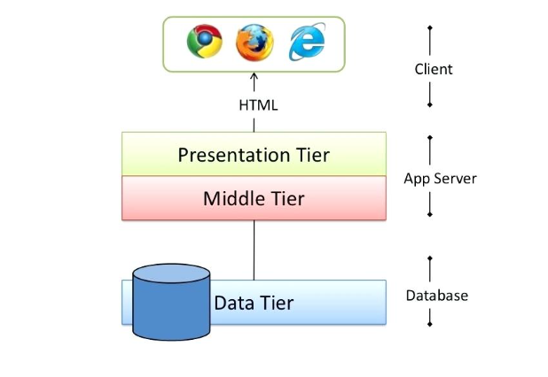

Figure 3: 3-tier architecture

3-tier architecture is used in this application by performing the following tasks below.

* The code for each layers are kept separately in different files.
* The presentation layer and business layer does not have direct access to database.
* The data layer cannot request issues regarding anything except for related database.

# **Chapter 4**

## **Project Planning**

* 1. **About WBS**

WBS is the process of defining smaller elements of the project to make each small element more manageable. WBS is not only used for scope management but also forms the framework for the majority of cost and time management of the project. The project can be broken down in several pieces depending upon the nature of work. It shows the hierarchy of system where the scope of working is divided into manageable work packages for the productivity and efficiency in the project.

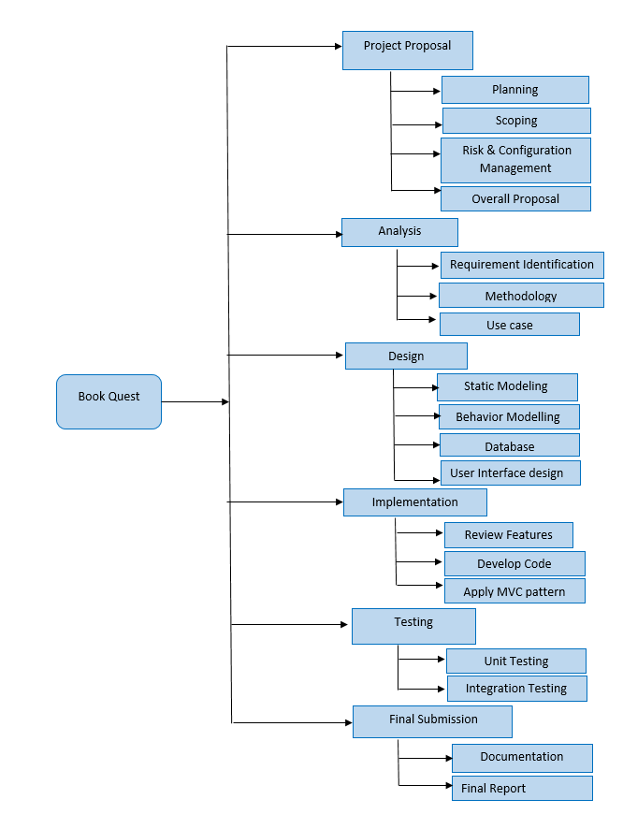

Figure 4: work breakdown structure

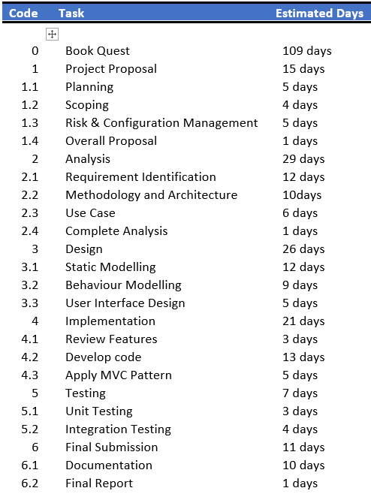

Figure 5: Schedule

* 1. **Milestone**

A Milestone is a reference point that marks a major event in a project management system and is used to monitor the project management process. Setting milestones for a project should present a clear sequence of events that will incrementally build up to the completion of the project. As you complete each milestone, you can update the status of your project accordingly. One other major feature of the project milestones is the task association and project planning which will help for the successful project. A milestone's start date and end date depends on the task's start date and end date.

|  |  |  |
| --- | --- | --- |
| **Milestones** | **Start Date** | **End Date** |
| Project proposal | 26 May, 2019 | 9 April, 2019 |
| Analysis | 10April, 2019 | 8 May, 2019 |
| Design | 9 May, 2019 | 3 June, 2019 |
| Implementation | 4 June, 2019 | 24 June, 2019 |
| Testing | 25 July, 2019 | 1 July, 2019 |
| Final Submission | 2 July, 2019 | 12 July, 2019 |

* Project proposal (26 May-9 April) - It consists of planning, scoping, risk and configuration management. This task is given 15 days.
* Analysis (10 April-8 May) - It consists of requirement identification, methodology and use case. This task is given 29 days.
* Design (9 May-3 June) - It consists of static modelling, dynamic modelling and user interface design. This task is given 26 days.
* Implementation (4 June-24 June) - It consists of review features, develop code, and apply MVC pattern. This task is given 21 days.
* Testing (25 June – 1 July) – It consists of unit testing and integration testing. This task is given 7 days.
* Final submission (2 July – 12 July) – It consists of documentation and final report. This task is given 11 days.

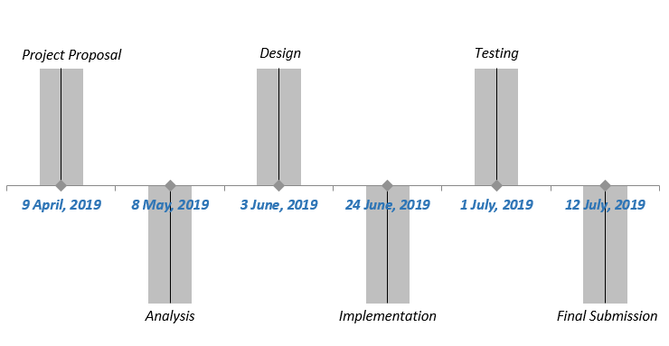

Figure 6: Milestone

* 1. **Gantt Chart**

A Gantt chart is constructed with a horizontal axis representing the total time span of the project, broken down into increments and a vertical axis representing the tasks that make up the project. It defines the overall project goals. This includes the start date, end date, and key milestones for the project.

It create tasks and set each task duration, assign resources to tasks, link dependant tasks i.e. Gantt charts show how different parts of a project are interconnected. Some tasks may be contingent on others.

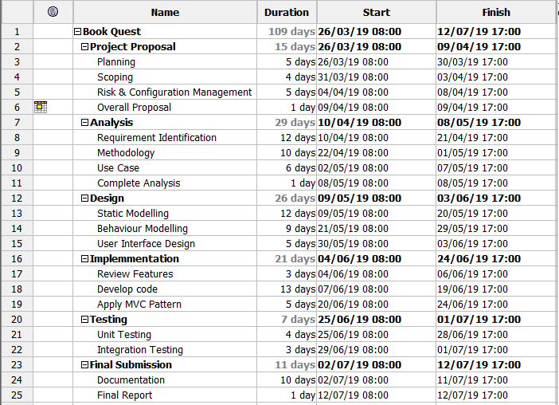

Figure 7: Gantt chart Schedule

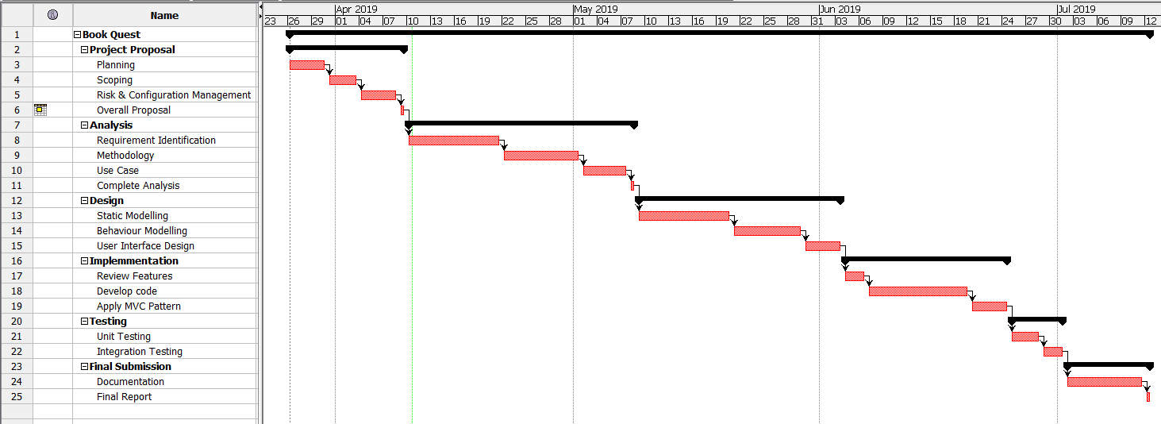

Figure 8: Gantt Chart

# **Chapter 5**

## **Risk Management**

Understanding the risks and effectively managing these type of threats helps to achieve the success in any project. Risk management is an important tool to eliminate the uncertainties of project. Risk are uncertain events which have both positive and negative aspects in it. In risk management potential risk are identified evaluated and attempted to minimize the impact of negative risk by keeping control on it.

The process of risk management system are

Identification of risk

Assessment of risk

Prioritization of risk

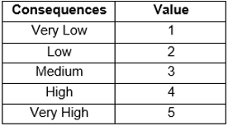

Figure 9: Consequences

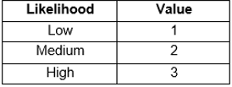

Figure 10: Likelihood

|  |  |  |  |  |
| --- | --- | --- | --- | --- |
| Risk | Likelihood | Consequences | Impact | Action |
| No advance technology available | 2 | 3 | 6 | Proper analysis  Enabling regular updates and patches |
| Running out of funds | 3 | 4 | 12 | Setting up cost control system |
| Wrong time estimation | 3 | 4 | 12 | Proper planning should be done |
| Natural calamites | 2 | 4 | 8 | Data should be backed up |
| Hardware failure | 3 | 5 | 15 | Regular maintenance should be done  Back up data |
| Virus and system error | 3 | 4 | 12 | Preventive measure should be taken before attack in the system  Anti- malware software should be install |
| Complexity in implementing design | 3 | 4 | 12 | Taking expert advice during development process  Enough research should be done |
| Hard disk Failure | 3 | 5 | 15 | Preferring cloud backup over physical backup |

# **Chapter 6**

## **Configuration Management**

It is a systems engineering process that ensures proper accounting of an enterprise’s configuration items (CIs) and also ensures the interrelationship between them in an operational environment. The configuration management process identifies and tracks the individual CIs, & their physical attributes and functional capabilities. For configuration management to operate it needs some form of mechanism in which to store the information it governs.

A folder ProjectCP is created and inside separate file for Proposal, Analysis, Design, Implementation, Testing, Project materials and backup is created. The project is stored in the files and backed up in backup folder so that if there is any failure in task it can be rolled back to the previous execution. The units of projects are pushed in github (<https://github.com/shristi7690>) on daily basis.

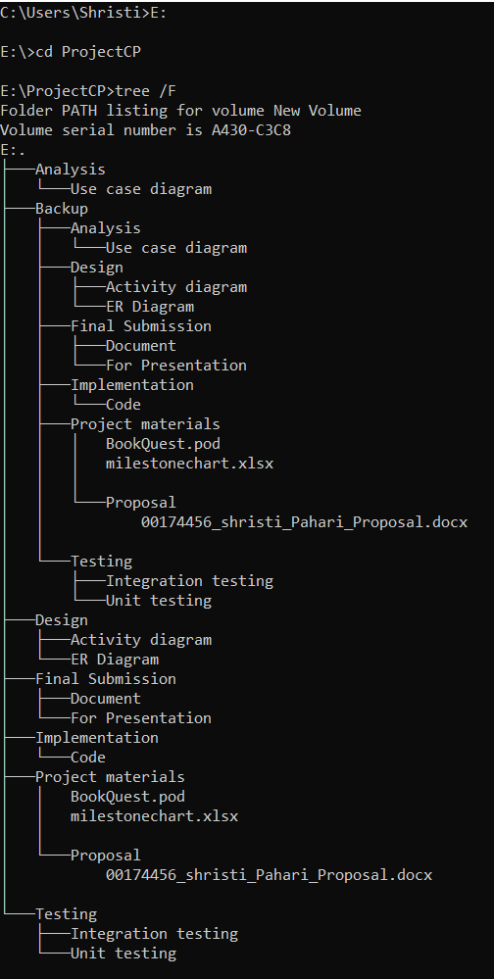

Figure 11: Configuration

# **Chapter 7**

## **Conclusion**

In this proposal, ‘Book Quest’ is introduced and identified. The scope, aims and objectives are described along with the limitations. Waterfall methodology and MVC design pattern is used to develop the software. WBS is used to break down the project into different tasks to make it more manageable for the productivity and efficiency. Gantt chart is used for more detailed description of tasks and its timeline. Also, the potential risk are identified and the action to reduce the risk are suggested. Then the system is configured to test the reliability of its performance.

# **Chapter 8**

## **References**

1. Project Concept(2016) Available at:

<https://dokorecyclers.com/>

[Accessed 29 Mar 2019]

1. MVC (2018) Available at:

<https://www.tutorialspoint.com/mvc_framework/mvc_framework_introduction.htm>

[Accessed 04 Apr 2019]

1. 3 Tier Architecture (2015) Available at:

https://searchsoftwarequality.techtarget.com/definition/3-tier-application

[Accessed 5 Apr 2019]

1. Work Breakdown Structure (2018) Available at:

<https://www.projectsmart.co.uk/work-breakdown-structure.php>

[Accessed 6 Apr 2019]

1. Configuration Management (2017) Available at:

<https://cmpic.com/configuration-management-definition.htm>

[Accessed 8 Apr 2019]